In-class Lab Exercise

Week 5

Question 1

Recursive Quick sort Algorithm

int split(vector<int>& array, int l, int h) {

    int key = array[h];

    int i = l - 1;

    for(int j=l; j < h; j++) {

        if(array[j] < key) {

            i++;

            swap(array[i], array[j]);

        }

    }

    swap(array[i + 1], array[h]);

    return i+1;

}

void quicksort(vector<int>& array, int l, int h) {

    if(l < h) {

        int pi = split(array, l, h);

        quicksort(array, l, pi - 1);

        quicksort(array, pi + 1, h);

    }

}

Non-recursive quick sort Algorithm

void nonrecquicksort(vector<int>& array, int n){

    stack<int> stk;

    int l = 0, r = n - 1;

    stk.push(l);

    stk.push(r);

    while (!stk.empty())

    {

        r = stk.top();

        stk.pop();

        l = stk.top();

        stk.pop();

        int i = l;

        int j = r;

        int key = array[(l + r) / 2];

        while (i <= j)

        {

            while (array[i] < key)

                i++;

            while (array[j] > key)

                j--;

            if (i <= j)

            {

                swap(array[i], array[j]);

                i++;

                j--;

            }

        }

        if (l < j){

            stk.push(l);

            stk.push(j);

        }

        if (i < r){

            stk.push(i);

            stk.push(r);

        }

    }

}

Terminal Output:-

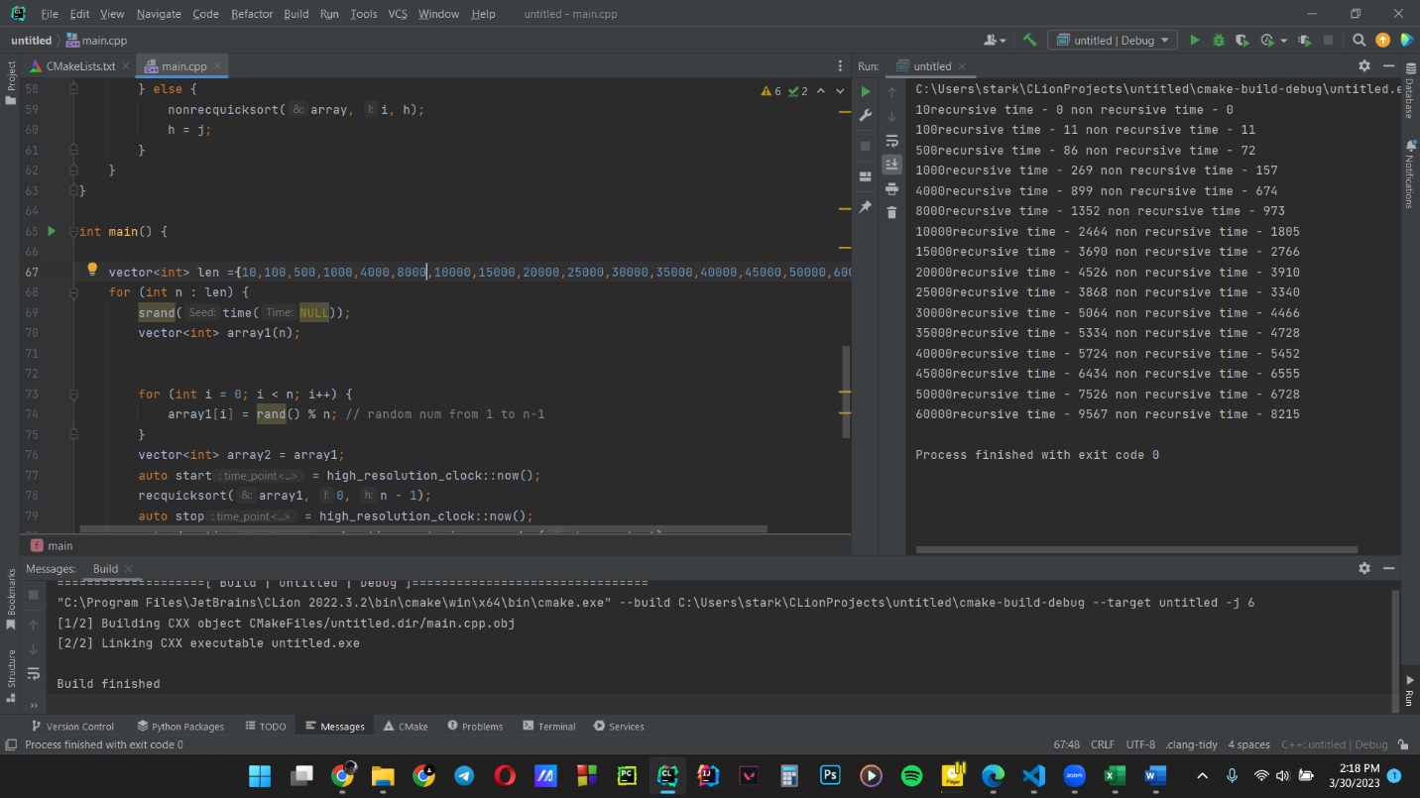

|  |  |  |
| --- | --- | --- |
| Length of Array | Recursive quick sort (Time in micro seconds) | Non-recursive quick sort (Time in micro seconds) |
| 10 | 0 | 0 |
| 100 | 11 | 11 |
| 500 | 86 | 72 |
| 1000 | 269 | 157 |
| 4000 | 899 | 674 |
| 8000 | 1352 | 973 |
| 10000 | 2464 | 1805 |
| 15000 | 3690 | 2766 |
| 20000 | 4526 | 3910 |
| 25000 | 3868 | 3340 |
| 30000 | 5064 | 4466 |
| 35000 | 5334 | 4728 |
| 40000 | 5724 | 5452 |
| 45000 | 6434 | 6555 |
| 50000 | 7526 | 6728 |
| 60000 | 9567 | 8215 |

Graph according to the data in the table

Discussion –

* For small sizes of arrays , recursive and non recursive implementations show same time results.
* But when we increase the number of elements in the arrays , recursive quick sort algorithm shows a much higher time taken .
* In theory the time complexity of both functions are O( nlog n).
* But when the input sizes get larger , the memory overhead becomes larger in recursive function because , it stores every recursive step in a stack that means for larger arrays the memory usage of recursive function is much higher.
* Our gathered data confirms that .
* But recursive method is easier to implement in the programmer’s side.

Question 2

Functions used for implementation

* Used quicksort algorithm

int split(vector<int>& array, int l, int h) {

    int key = array[h];

    int i = l - 1;

    for(int j=l; j < h; j++) {

        if(array[j] < key) {

            i++;

            swap(array[i], array[j]);

        }

    }

    swap(array[i + 1], array[h]);

    return i+1;

}

void recquicksort(vector<int>& array, int l, int h) {

    if(l < h) {

        int pi = split(array, l, h);

        recquicksort(array, l, pi - 1);

        recquicksort(array, pi + 1, h);

    }

}

* Created a function median(array)

float median(vector<int> array){

    int x = array.size();

    int y = array.size()/2;

    if (x==1)   //if size is 0 return only number

        return array[0];

    else if (x % 2 ==0) // if even elements should get 2

        // mid numbers in sorted array and get average of both

        return ((array[y-1]+array[y])/2.0);

    else // if odd elements get the middle number of sorted arr

        return array[y];

}

* Main

int main() {

    int n ;

    cin>>n;

    srand(time(NULL));

    vector<int> array;

    for (int i = 0; i < n; i++) {

        array.push_back(rand() % n); // random num adding from 1 to n-1

        }

    //got a random vector array in size n

    for (int z: array)

        cout<<z<<" ";

    cout<<endl;

    for( int i = 0 ; i <n ; i++){

        vector<int> sarr(array.begin(),array.begin()+i+1);

        //getting the sub arrays from size 0 to n

        recquicksort(sarr,0,i);      //sorting using quicksort

        cout<<"after adding the number sorted sub array : ";

        for (int z: sarr)

            cout<<z<<" ";

        cout<<endl;

        cout<<"Median is "<<median(sarr)<<endl;

    }

}

Console outputs examples

For size 5

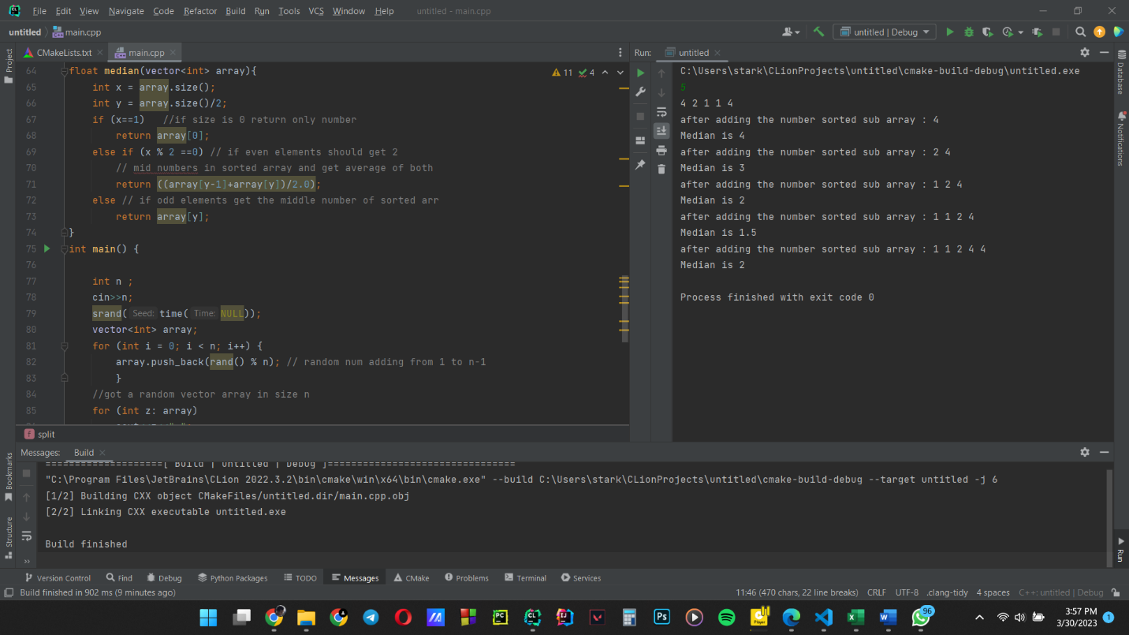

For size 10

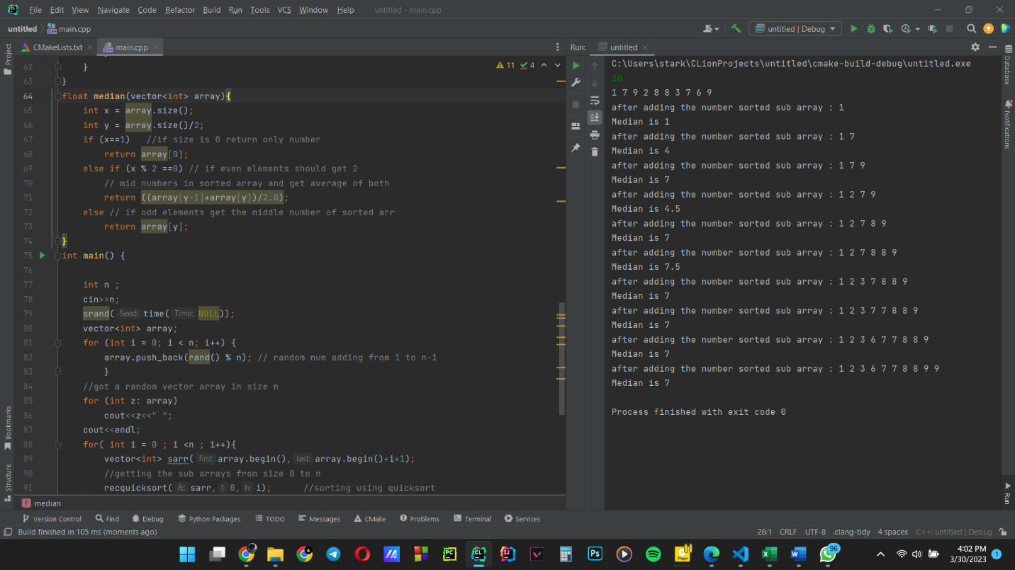

GITHUB link

https://github.com/ManadaHerath/Sorting-Algorithms.git